

C PROJECT REPORT ON
MINI LIBRARY CATALOG

SUBMITTED TO
The Technical Department
KG College of Arts and Science

SUBMITTED BY
Student Name | Roll No. | Course & Batch
SHARAL M | 25BIT149 | BSc IT(2025 - 2028)
SHANYUKTHA D | 25BIT148 | BSc IT(2025 - 2028)
SELVAMALINI S | 25BIT147 | BSc IT(2025 - 2028)
SHASTIKA L | 25BIT150 | BSc IT(2025 - 2028)
SHIFA ALMAS S | 25BIT151 | BSc IT(2025 - 2028)
SIRANJEEV D | 25BIT152 | BSc IT(2025 - 2028)

Academic Year: 2025 – 2026
Semester: I

DECLARATION
We hereby declare that the project entitled “MINI LIBRARY CATALOG" submitted in partial fulfilment of the requirements for the course [C Programming] is a record of our original work carried out under the guidance of [Vasanth M], Technical Trainer, Technical Department, KGiSL MicroCollege.
We further declare that this project has not been submitted previously, either in part or in full, for the award of any degree, diploma, or other similar title, at this or any other institution.
We have acknowledged all sources of information used in this project wherever applicable.
Student Name | Roll No. | Course & Batch | Signature
SHARAL M | 25BIT149 | BSc IT(2025 - 2028)
SHANYUKTHA D | 25BIT148 | BSc IT(2025 - 2028)
SELVAMALINI S | 25BIT147 | BSc IT(2025 - 2028)
SHASTIKA L | 25BIT150 | BSc IT(2025 - 2028)
SHIFA ALMAS S | 25BIT151 | BSc IT(2025 - 2028)
SIRANJEEV D | 25BIT152 | BSc IT(2025 - 2028)

Place: COIMBATORE
Date: ______________

CERTIFICATE
This is to certify that the project entitled “MINI LIBRARY CATALOG" is a bona fide work carried out by the following students of [BSc IT ‘B’(2025 - 2028)], [BSc Information Technology], KG College of Arts & Science, in partial fulfilment of the requirements for the course [C Programming].
This project has been completed under my supervision and guidance during the academic period [Month, Year].
It is further certified that this project is the original work of the students and has not been previously submitted for the award of any degree, diploma, or certificate at this or any other institution.
Project Team:
S. No. | Name | Roll Number
1. | SHARAL M | 25BIT149
2. | SHANYUKTHA D | 25BIT148
3. | SELVAMALINI S | 25BIT147
4 | SHASTIKA L | 25BIT150
5. | SHIFA ALMAS S | 25BIT151
6. | SIRANJEEV D | 25BIT152

Guide: Head of the Department
(Technical Trainer, KGM) (Technical Head, KGM)

______________________ _______________________

Place: Coimbatore
Date:

ABSTRACT
The project “Mini Library Catalog System” is developed in the C programming language to automate the management of library records. The main objective of this project is to simplify and organize the process of maintaining book details, searching records, and managing basic library operations efficiently.
The system allows users to add, view, search, and delete book records by entering details such as book title, author name, book ID, and availability status. It provides an easy-to-use interface where users can quickly retrieve information about books stored in the catalog. The system also supports updating records and maintaining data in a structured format.
This project demonstrates the effective use of arrays, structures, functions, and file handling in C to build a well-organized and efficient application. The design emphasizes simplicity, accuracy, and ease of use, making it suitable for small libraries or academic purposes.
Through this project, fundamental concepts of structured programming, data management, modular design, and file processing have been successfully implemented. It enhances logical thinking and problem-solving skills while providing practical exposure to real-world applications in software development, particularly in the field of information management systems.

TABLE OF CONTENTS
S. No. | Topics | Page. No.
1 | Introduction
1.1 | Objective
1.2 | Overview
1.3 | Features
2 | Program Analysis
2.1 | Problem Definition
2.2 | Project Overview
2.3 | Scopes and Limitations
3 | System Design
3.1 | Modules
4 | Methodology
4.1 | Problem Analysis
4.2 | System Design
4.3 | Program Development
4.4 | Testing and Validation
4.5 | Result and Documentation
4.6 | Algorithm
4.7 | Flowchart
5 | Source Code
6 | Input and Output Screens
7 | Discussion and Conclusion
7.1 | Discussion
7.2 | Conclusion
8 | References

- INTRODUCTION

1.1 Objective
- To design and develop a Mini Library Catalog System using the C programming language.
- To automate the process of managing book records such as adding, searching, updating, and deleting books.
- To demonstrate structured programming concepts — arrays, loops, conditional statements, functions, and file handling (optional).

1.2 Overview
This system allows users (librarians or administrators) to:
- Add new books to the catalog.
- View all available books in the library.
- Search for books by title, author, or ID.
- Delete or update book records.
- Maintain a simple digital catalog for easy access and organization.

1.3 Features
- Menu-driven interface for easy navigation.
- Book records stored using structures.
- Search functionality for quick retrieval.
- Add, delete, and update operations.
- Option to save records in a text file.
- Simple and efficient console-based system.

- PROGRAM ANALYSIS

2.1 Problem Definition
Managing library records manually is time-consuming and error-prone. A system is required to:
- Store book details efficiently.
- Allow quick searching and updating of records.
- Maintain organized data for easy access.

2.2 Project Overview
Aspect | Description
Language Used | C
Compiler | GCC / Dev-C++ / Turbo C++
Concepts Used | Arrays, Structures, Functions, Loops, Conditional Statements
I/O Type | Console-based
Optional | File Handling for record storage

2.3 Scopes and Limitations
Scope:
- Suitable for small libraries and academic projects.
- Can be extended to include student records and issue/return system.
Limitations:
- Works only in console mode.
- No graphical interface.
- Limited storage (fixed array size).

- SYSTEM DESIGN
3.1 Modules
Module Name | Description
Book Entry Module | Allows the user to add new book details such as ID, title, author, and availability.
Display Module | Displays all books stored in the catalog in a formatted manner.
Search Module | Searches for a book using ID or title.
Update/Delete Module | Updates book details or removes records from the catalog.
File Storage Module(Optional) | Saves book records into a file for permanent storage.
Exit Module | Terminates the program safely.
Module Interaction Overview
- Add Book → stores new book data.
- Display Books → shows all records.
- Search Book → retrieves specific book.
- Update/Delete → modifies records.
- File Storage → saves data.
- Exit → ends program.

- METHODOLOGY
4.1. Problem Analysis
The manual library system was analyzed and issues like difficulty in searching and maintaining records were identified. The solution was to create a digital catalog system.
4.2. System Design
Designed structures like Book.
- Planned modules for adding, searching, and displaying data.
- Created flowcharts and algorithms before coding.

4.3. Program Development
Implemented using C language.
- Used arrays and structures to store book data.
- Modular functions used for each operation.

4.4. Testing and Validation
Tested with different inputs.
- Checked search accuracy and data handling.
- Verified correct functionality of all modules.
4.5. Result and Documentation
The system successfully manages library records.
- Outputs are clear and structured.
- Documentation prepared for easy understanding
4.6. Algorithm
Steps:
- Start the program.
- Display menu options.
- Read user choice.
- Perform operation:
  - Add book
  - Display books
  - Search book
  - Delete book
- Repeat until user exits.
- End program.

Importance
Provides structured logic.
- Improves clarity and efficiency.
- Helps in debugging and development.
4.7. Flowchart
Explanation of Flow
- Start
- Display Menu
- Enter Choice
- Perform Operation (Add/Search/Delete/View)
- Repeat
- End

START

ADD NEW BOOK

Book ID,Author,Title,Publisher,Quantity

DISPLAY ALL BOOKS

SEARCH BOOK

By Book ID,Author

UPDATE BOOK DETAILS

DELETE BOOK RECORD

EXIT

END

- SOURCE CODE

#include <stdio.h>
#include <stdlib.h>
#include <string.h>

#define FILENAME "books.dat"

struct Book {
char book_id[20];
char title[50];
char author[50];
char publisher[50];
int quantity;
};

void addBook(void);
void displayBooks(void);
void searchBook(void);
void updateBook(void);
void deleteBook(void);

int main() {
int choice;
while (1) {
printf("\n===== BOOK MANAGEMENT SYSTEM =====\n");
printf("1. Add New Book\n");
printf("2. Display All Books\n");
printf("3. Search Book\n");
printf("4. Update Book Details\n");
printf("5. Delete Book Record\n");
printf("6. Exit\n");
printf("Enter your choice (1-6): ");
if (scanf("%d", &choice) != 1) {
printf("Invalid input.\n");
exit(1);
}
getchar();
switch (choice) {
case 1: addBook(); break;
case 2: displayBooks(); break;
case 3: searchBook(); break;
case 4: updateBook(); break;
case 5: deleteBook(); break;
case 6: printf("Exiting program.\n"); exit(0);
default: printf("Invalid choice.\n");
}
}
return 0;
}

void addBook(void) {
struct Book book;
FILE *fp = fopen(FILENAME, "ab");
if (!fp) { printf("File error.\n"); return; }

printf("Enter Book ID: ");
fgets(book.book_id, sizeof(book.book_id), stdin);
book.book_id[strcspn(book.book_id, "\n")] = '\0';

printf("Enter Title: ");
fgets(book.title, sizeof(book.title), stdin);
book.title[strcspn(book.title, "\n")] = '\0';

printf("Enter Author: ");
fgets(book.author, sizeof(book.author), stdin);
book.author[strcspn(book.author, "\n")] = '\0';

printf("Enter Publisher: ");
fgets(book.publisher, sizeof(book.publisher), stdin);
book.publisher[strcspn(book.publisher, "\n")] = '\0';

printf("Enter Quantity: ");
if (scanf("%d", &book.quantity) != 1) {
printf("Invalid number.\n");
fclose(fp);
getchar();
return;
}
getchar();

fwrite(&book, sizeof(struct Book), 1, fp);
fclose(fp);
printf("Book added successfully.\n");
}

void displayBooks(void) {
struct Book book;
FILE *fp = fopen(FILENAME, "rb");
if (!fp) { printf("No books found.\n"); return; }

printf("\nAll Books:\n");
printf("------------------------------------------------------------\n");
while (fread(&book, sizeof(struct Book), 1, fp) == 1) {
if (strlen(book.book_id) > 0)
printf("ID: %s | Title: %s | Author: %s | Publisher: %s | Qty: %d\n",
book.book_id, book.title, book.author, book.publisher, book.quantity);
}
printf("------------------------------------------------------------\n");
fclose(fp);
}

void searchBook(void) {
struct Book book;
FILE *fp = fopen(FILENAME, "rb");
if (!fp) { printf("No books found.\n"); return; }

int choice;
char term[50];
int found = 0;

printf("Search by: 1. Book ID 2. Title\nEnter choice: ");
if (scanf("%d", &choice) != 1) { fclose(fp); return; }
getchar();

printf("Enter search term: ");
fgets(term, sizeof(term), stdin);
term[strcspn(term, "\n")] = '\0';

while (fread(&book, sizeof(struct Book), 1, fp) == 1) {
if ((choice == 1 && strcmp(book.book_id, term) == 0) ||
(choice == 2 && strcmp(book.title, term) == 0)) {
printf("Book Found:\n");
printf("ID: %s\nTitle: %s\nAuthor: %s\nPublisher: %s\nQuantity: %d\n",
book.book_id, book.title, book.author, book.publisher, book.quantity);
found = 1;
break;
}
}
if (!found) printf("Book not found.\n");
fclose(fp);
}

void updateBook(void) {
struct Book book;
FILE *fp = fopen(FILENAME, "rb+");
if (!fp) { printf("No books found.\n"); return; }

char id[20];
int found = 0;

printf("Enter Book ID to update: ");
fgets(id, sizeof(id), stdin);
id[strcspn(id, "\n")] = '\0';

while (fread(&book, sizeof(struct Book), 1, fp) == 1) {
if (strcmp(book.book_id, id) == 0) {
char temp[50];
printf("Enter new Title (leave blank to keep): ");
fgets(temp, sizeof(temp), stdin);
temp[strcspn(temp, "\n")] = '\0';
if (strlen(temp)) strcpy(book.title, temp);

printf("Enter new Author (leave blank to keep): ");
fgets(temp, sizeof(temp), stdin);
temp[strcspn(temp, "\n")] = '\0';
if (strlen(temp)) strcpy(book.author, temp);

printf("Enter new Publisher (leave blank to keep): ");
fgets(temp, sizeof(temp), stdin);
temp[strcspn(temp, "\n")] = '\0';
if (strlen(temp)) strcpy(book.publisher, temp);

printf("Enter new Quantity (-1 to keep): ");
int qty;
if (scanf("%d", &qty) == 1 && qty >= 0)
book.quantity = qty;
getchar();

fseek(fp, -sizeof(struct Book), SEEK_CUR);
fwrite(&book, sizeof(struct Book), 1, fp);
printf("Book updated.\n");
found = 1;
break;
}
}
if (!found) printf("Book not found.\n");
fclose(fp);
}

void deleteBook(void) {
struct Book book;
FILE *fp = fopen(FILENAME, "rb");
FILE *temp = fopen("temp.dat", "wb");
if (!fp || !temp) { printf("File error.\n"); return; }

char id[20];
int found = 0;

printf("Enter Book ID to delete: ");
fgets(id, sizeof(id), stdin);
id[strcspn(id, "\n")] = '\0';

while (fread(&book, sizeof(struct Book), 1, fp) == 1) {
if (strcmp(book.book_id, id) == 0) { found = 1; continue; }
fwrite(&book, sizeof(struct Book), 1, temp);
}

fclose(fp);
fclose(temp);
remove(FILENAME);
rename("temp.dat", FILENAME);

if (found) printf("Book deleted.\n");
else printf("Book not found.\n");
}

SOURCE CODE EXPLANATION:

1) Structures
- Book stores ID, title, and author.

2) Menu System
- Uses switch-case for operations.

3) Add Book
- Stores user input into array.

4) Display Books
- Iterates and prints all records.

5) Search Book
- Finds book using ID.

6) Exit
- Terminates program

- INPUT AND OUTPUT SCREENS
Input Screen 1:
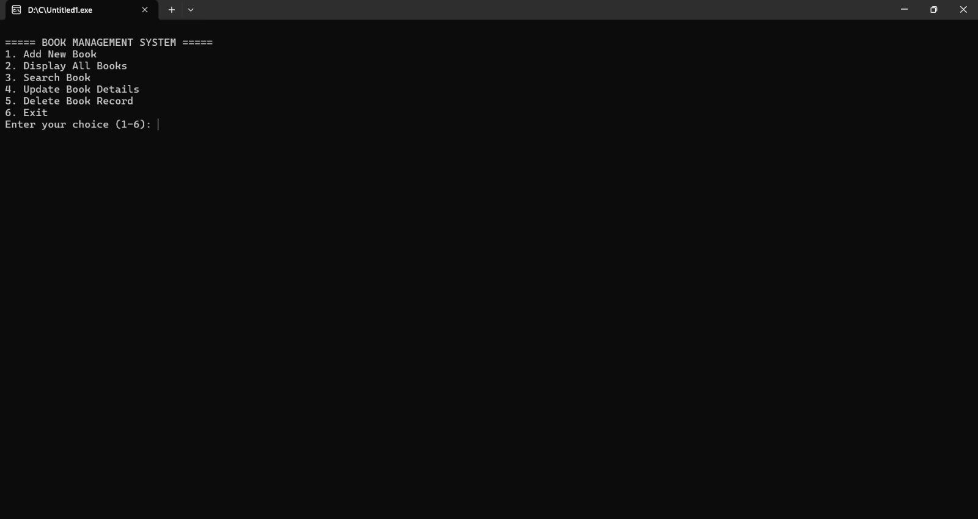
Output Screen:
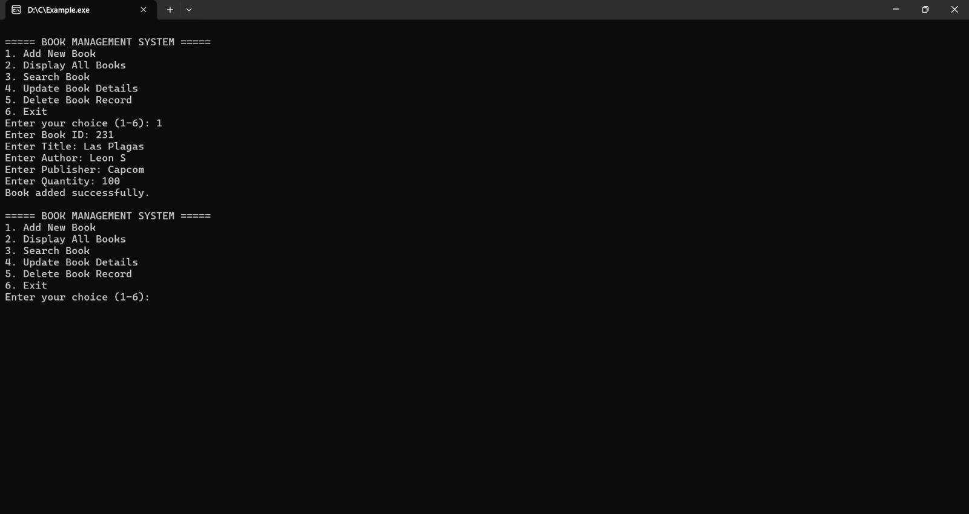
- DISCUSSION & CONCLUSION

7.1 Discussion
Demonstrates structured programming.
- Efficient for small-scale library systems.
- Easy to understand and modify.
7.2 Conclusion
Successfully developed a functional catalog system.
- Achieved automation of book record management.
- Can be extended with advanced features like database integration.

- REFERENCES

- Kernighan & Ritchie, The C Programming Language
- TutorialsPoint – C Programming
- GeeksforGeeks – Library Management System
- Dev-C++ User Manual

